Screen Capture: How to Crop an Image and Save as a JPEG

Step 1: Press the Print Screen Button on your laptop to save the screen you see (including the small image you want)
NOTE: It might say “prtsc” or “prtscn”. If it says this in BLUE, you also need to hold down the function key (it says “fn”) while you press the print screen key.

Step 2: Open the program called “Paint”

Step 3: Press the control key and “V” at the same time

Step 4: Pick the Crop Tool and Draw a box around the image you want to save
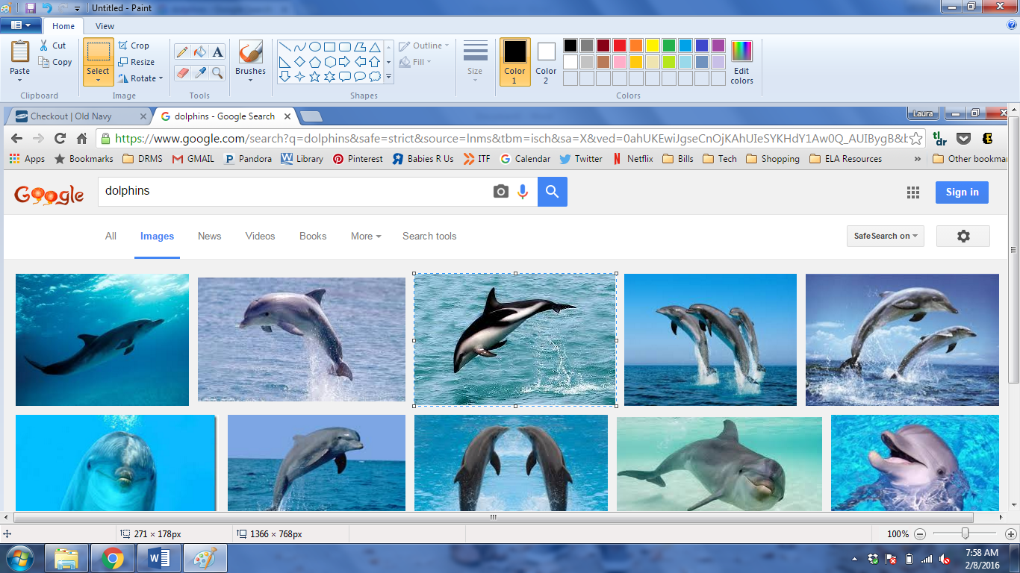

Step 5: Once you have a box around the image you want, press the Control Key and the “C” key at the same time

Step 6: Press the Control Key and the “N” key at the same time (This is to open a new document)

Step 7: Click “Don’t Save” when you get that prompt in the box
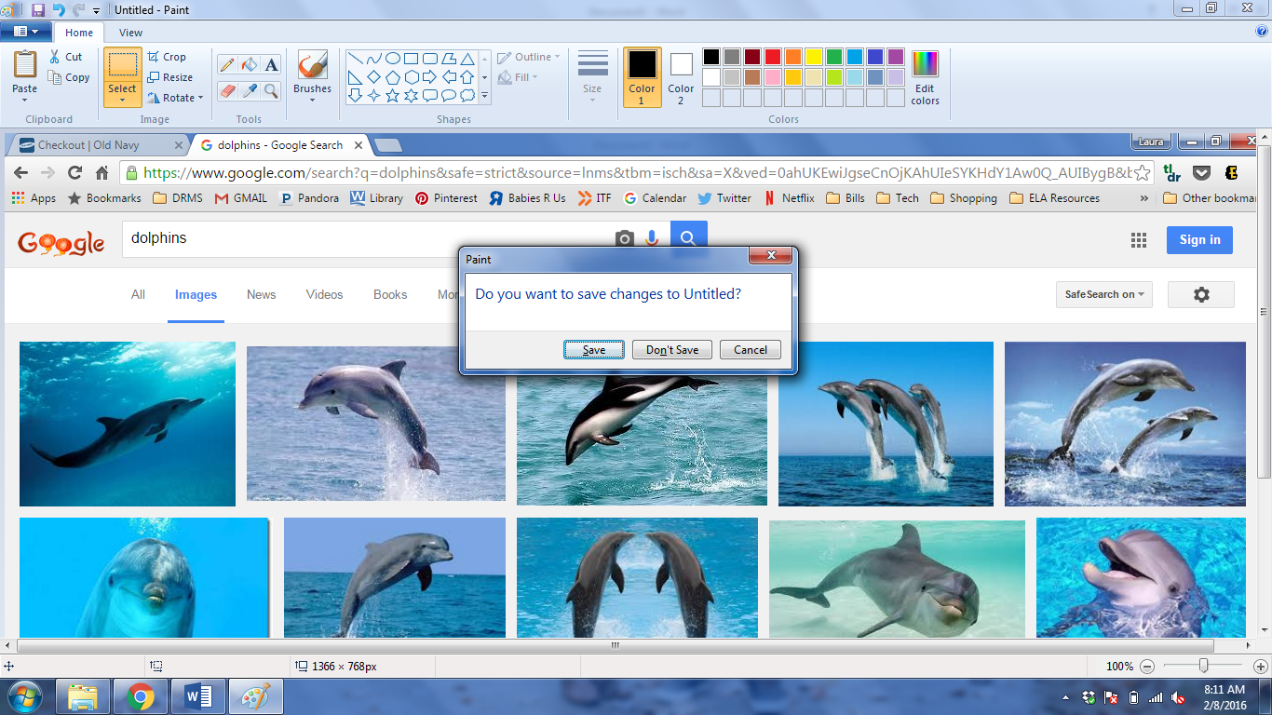

Step 8: Once a new window has opened, press the Control Key and the “V” key to paste your image

Step 9: Click the grey area to pull up the tabs on the white box near your image. You need to get rid of any white space, because the computer will include that in your image. Drag the white space in, so that you can ONLY see your image.

Step 10: Click the top left corner of your screen, click “Save As”, and choose “JPEG”
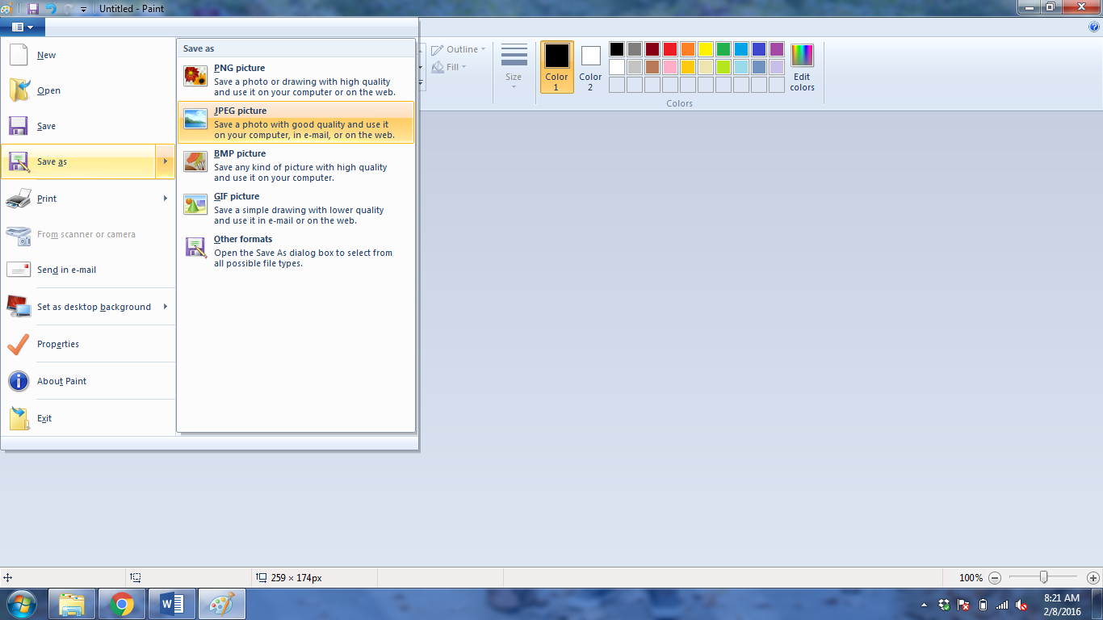

Step 11: Click your student harddrive on the left, label your image “Ancestry- ____________”, double-check that that image is a JPEG, and click Save.
